Expense Tracker Mini Project

Introduction
Analyzing Personal Expenses is a project aimed at simulating a comprehensive expense tracker using technologies like Python, SQL, and Streamlit, with applications in personal finance management. The project leverages the Faker library to generate realistic monthly expense data, which is then stored in a SQL database. Through Exploratory Data Analysis (EDA) and SQL queries, spending patterns and trends are analyzed.
A Streamlit web application was developed to showcase visualizations and insights, answering critical questions such as total spending per category, payment mode analysis, and more. Additionally, the project identifies high-priority spending areas and highlights potential savings strategies.
This project demonstrates practical applications like automating expense tracking, creating financial dashboards, and providing actionable recommendations to optimize personal or business financial management. It concludes with a fully functional and interactive app, showcasing results derived from SQL queries and delivering actionable financial insights.

Methodology

1. Problem Understanding and Objective Definition
- Objective: To simulate and analyze personal expense data, derive insights into spending habits, and develop a user-friendly app for visualization.

2. Data Simulation
- Utilize the Faker library to generate synthetic monthly expense data.
- Simulate key attributes like transaction date, category, payment mode, description, amount, and cashback.
- Ensure data realism:
  - Align date ranges with a calendar year.
  - Categorize expenses (e.g., food, transportation, bills, subscriptions).
  - Define logical ranges for transaction amounts and cashback values.

3. Database Design and Data Storage
- Database Schema:
  - Design a relational schema with 12 tables (one for each month).
  - Define fields such as Date, Category, Payment Mode, Description, Amount, and Cashback.
- Data Loading:
  - Populate tables with simulated data.
  - Use SQL for querying and analysis.

4. Exploratory Data Analysis (EDA)
- Use Python libraries like Pandas:
  - Analyze spending distribution across categories and months.
  - Identify high- and low-priority spending areas.

5. SQL Integration
- Develop SQL queries to answer the predefined questions, including:
  - Total spending per category and payment mode.
  - Cashback received across all transactions.
  - Monthly spending trends.
- Formulate 10–15 additional queries to derive deeper insights.

6. Streamlit Application Development
- Build an interactive Streamlit web app to:
  - Display visualizations (e.g., bar charts, pie charts) of spending patterns.
  - Showcase SQL query results in a user-friendly interface.

7. Insights and Recommendations
- Analyze SQL query outputs and visualization results to:
  - Highlight significant spending trends.
  - Provide actionable recommendations for financial optimization.
- Example Insights:
  - Categories contributing the most to total spending.
  - Months with high expenses or recurring costs.
  - Opportunities for cashback maximization.

Analysis
The project successfully simulates a personal expense tracker using synthetic data generated with the Faker library. It integrates Python, SQL, and Streamlit to analyze and visualize spending habits effectively. The insights provided by this project can help individuals or businesses better understand their financial patterns and optimize expenses.

Insights from the Analysing Personal Expenses Project

1. Spending Behavior
- Category Analysis:
  - Identified top categories where most expenses occurred (e.g., groceries, bills, subscriptions).
  - Highlighted low-priority categories that could be optimized for savings.
- Cashback Utilization:
  - Transactions offering cashback were minimal but impactful for reducing net expenses.
  - Specific payment modes provided better cashback benefits.

2. Monthly Trends
- Spending Peaks:
  - Certain months (e.g., festive seasons or holidays) showed higher expenditures in categories like gifts, entertainment, and travel.
  - Recurring expenses (e.g., insurance premiums, subscriptions) were consistent across specific months.
- Seasonal Patterns:
  - Grocery spending increased during weekends and specific times of the year, reflecting seasonal buying trends.

3. Payment Preferences
- Mode of Payment:
  - Online payment methods were more frequently used, possibly due to convenience and cashback offers.
  - Cash payments were predominantly used for smaller, day-to-day transactions.

4. Cashback and Rewards
- Cashback Trends:
  - Months with higher cashback correlated with increased spending in certain categories, indicating strategic use of rewards.
  - Cashback opportunities were better leveraged during larger transactions.

5. High-Value Insights
- Top Expense Drivers:
  - Categories like rent, subscriptions, and transportation contributed the most to overall spending.
- Cost Analysis of Travel:
  - Travel expenses showed a breakdown into significant components such as flights, accommodation, and local transportation.
  - Higher travel costs often coincided with holiday seasons.
- Recurring Patterns:
  - Subscription services showed consistent spending behavior and could be optimized by evaluating necessity.

6. Financial Optimization Opportunities
- Savings Opportunities:
  - Reducing spending in high-expenditure categories like entertainment and dining out could save up to 10–15% annually.
- Effective Budgeting:
  - Monthly expense tracking helped identify budget surpluses or shortfalls.
  - Suggested setting aside reserves during high-spending months based on historical trends.

Process
Step 1: install pandas faker and import it to you notebook
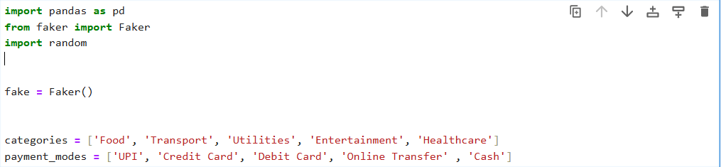
Step 2: generate data using faker
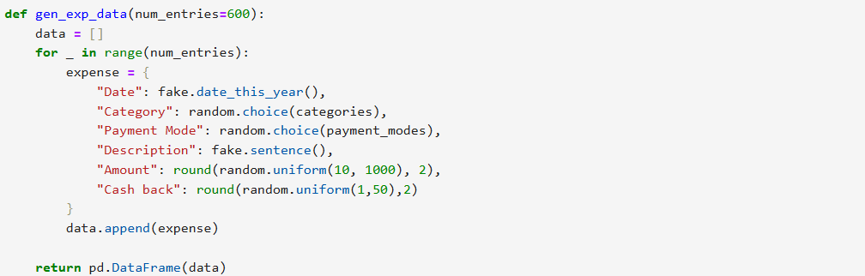
Step 3: generate table
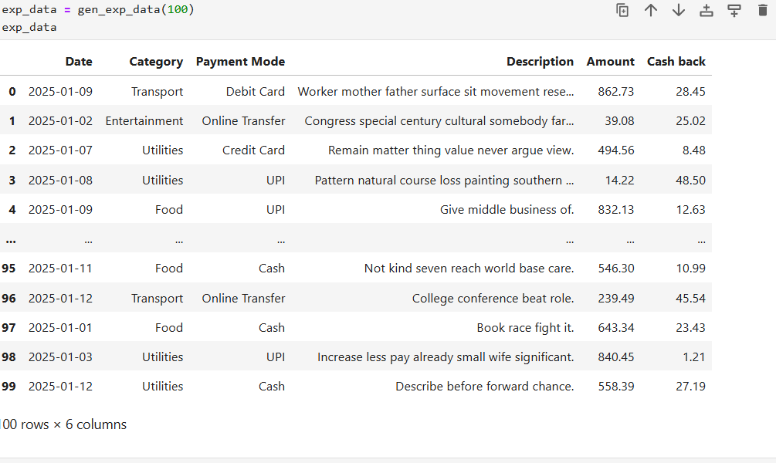
Step 4: intall mysql connector, import it to the notebook and establish connection with your local sql server
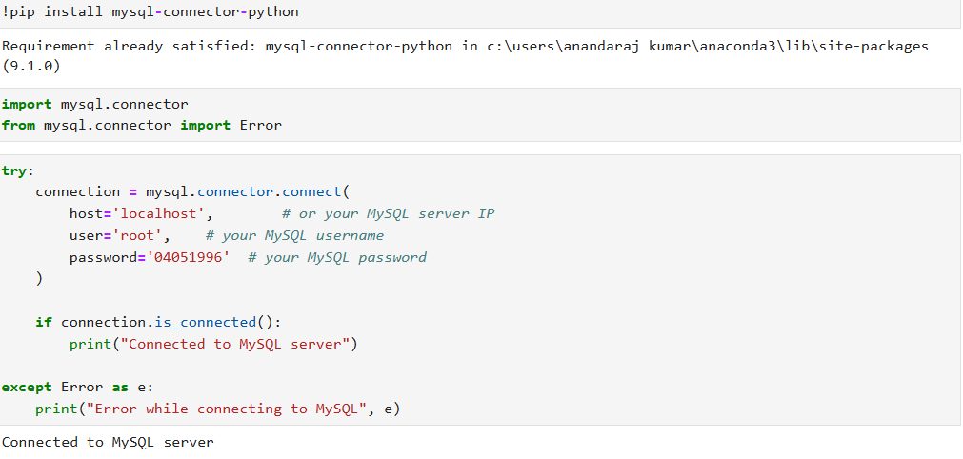
Step 5: after establish connection create database and insert generated faker data to a table in database
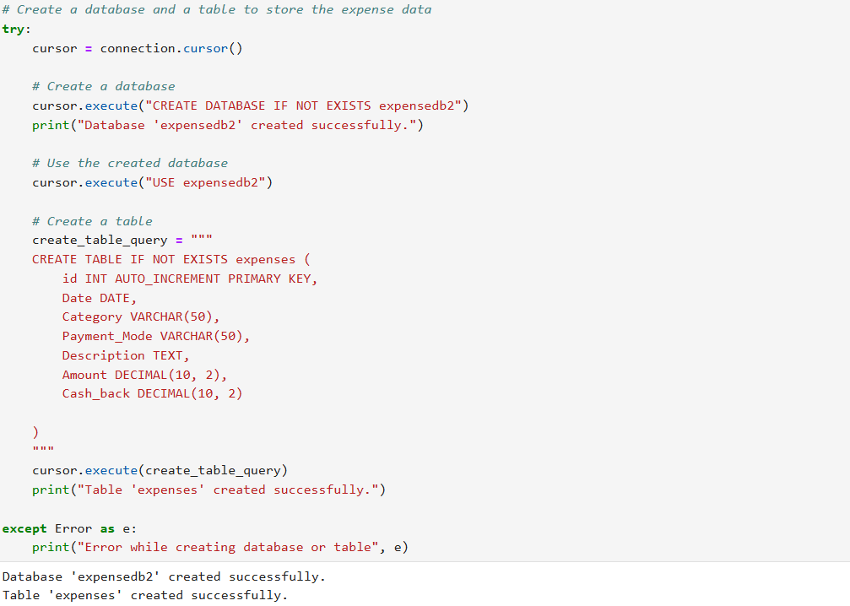

Step 6: after creating database and table close the connection to SQL
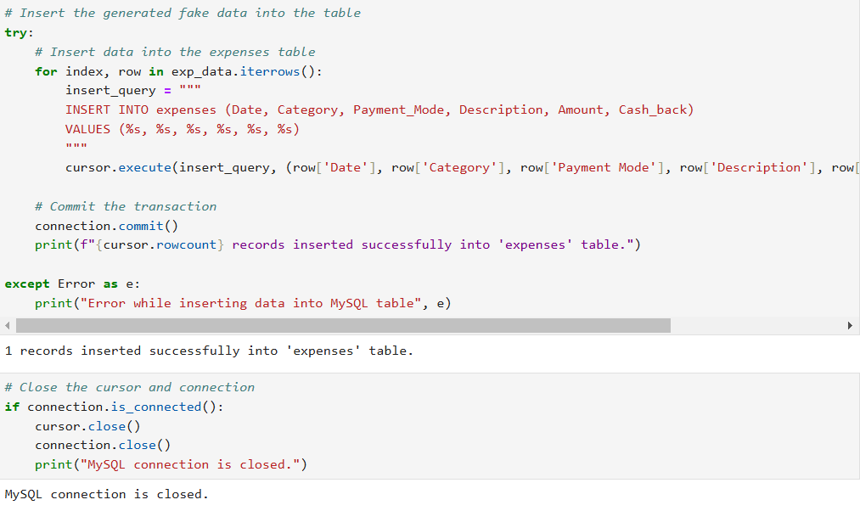
Step 7: Install and Import streamlit to your IDE

PythonFile Code for integrating SQL Queries to Streamlit

import streamlit as st
import mysql.connector
import pandas as pd
from mysql.connector import Error
import matplotlib.pyplot as plt

def create_connection():
connection = None
try:
connection = mysql.connector.connect(
host='localhost', # or your MySQL server IP
user='root', # your MySQL username
password='04051996', # your MySQL password
database='expensedb1' # your database name
)
if connection.is_connected():
st.success("Connected to MySQL server")
except Error as e:
st.error(f"Error while connecting to MySQL: {e}")
return connection

def fetch_data(query):
connection = create_connection()
if connection:
df = pd.read_sql(query, connection)
connection.close()
return df
return None

st.title("Expense Tracker")

# 1. Total amount spent in each category
if st.button("Total Amount Spent in Each Category"):
query = "SELECT Category, SUM(Amount) AS Total_Amount FROM expenses GROUP BY Category"
category_data = fetch_data(query)
if category_data is not None:
st.bar_chart(category_data.set_index('Category'))

# 2. Total amount spent using each payment mode
if st.button("Total Amount Spent by Payment Mode"):
query = "SELECT Payment_Mode, SUM(Amount) AS Total_Amount FROM expenses GROUP BY Payment_Mode"
payment_data = fetch_data(query)
if payment_data is not None:
st.bar_chart(payment_data.set_index('Payment_Mode'))

# 3. Total cashback received across all transactions
if st.button("Total Cashback Received"):
query = "SELECT SUM(Cash_back) AS Total_Cash_Back FROM expenses"
cashback_data = fetch_data(query)
st.write(cashback_data)

# 4. Top 5 most expensive categories
if st.button("Top 5 Most Expensive Categories"):
query = "SELECT Category, SUM(Amount) AS Total_Amount FROM expenses GROUP BY Category ORDER BY Total_Amount DESC LIMIT 5"
top_categories = fetch_data(query)
st.write(top_categories)

# 5. Spending on transportation using different payment modes
if st.button("Transportation Spending by Payment Mode"):
query = "SELECT Payment_Mode, SUM(Amount) AS Total_Amount FROM expenses WHERE Category = 'Transport' GROUP BY Payment_Mode"
transport_data = fetch_data(query)
if transport_data is not None:
st.bar_chart(transport_data.set_index('Payment_Mode'))

# 6. Transactions that resulted in cashback
if st.button("Transactions with Cashback"):
query = "SELECT * FROM expenses WHERE Cash_back > 0"
cashback_transactions = fetch_data(query)
st.write(cashback_transactions)

# 7. Total spending in each month of the year
if st.button("Total Spending by Month"):
query = "SELECT DATE_FORMAT(Date, '%Y-%m') AS Month, SUM(Amount) AS Total_Amount FROM expenses GROUP BY Month ORDER BY Month"
monthly_spending = fetch_data(query)
if monthly_spending is not None:
st.line_chart(monthly_spending.set_index('Month'))

# 8. Months with highest spending in specific categories
if st.button("Highest Spending in Travel, Entertainment, Gifts"):
query = """
SELECT DATE_FORMAT(Date, '%Y-%m') AS Month, Category, SUM(Amount) AS Total_Amount
FROM expenses
WHERE Category IN ('Travel', 'Entertainment', 'Gifts')
GROUP BY Month, Category
ORDER BY Month, Total_Amount DESC
"""
specific_category_data = fetch_data(query)
st.write(specific_category_data)

# 9. Recurring expenses during specific months
if st.button("Recurring Expenses by Month"):
query = """
SELECT Category, COUNT(*) AS Count, MONTH(Date) AS Month
FROM expenses
GROUP BY Category, Month
HAVING Count > 1
"""
recurring_expenses = fetch_data(query)
st.write(recurring_expenses)
# 10. Cashback or rewards earned in each month
if st.button("Cashback Earned by Month"):
query = "SELECT DATE_FORMAT(Date, '%Y-%m') AS Month, SUM(Cash_back) AS Total_Cash_Back FROM expenses GROUP BY Month ORDER BY Month"
cashback_by_month = fetch_data(query)
if cashback_by_month is not None:
st.line_chart(cashback_by_month.set_index('Month'))

# 11. Overall spending trend over time
if st.button("Overall Spending Trend"):
query = "SELECT DATE_FORMAT(Date, '%Y-%m') AS Month, SUM(Amount) AS Total_Amount FROM expenses GROUP BY Month ORDER BY Month"
spending_trend = fetch_data(query)
if spending_trend is not None:
st.line_chart(spending_trend.set_index('Month'))

# 12. Typical costs associated with different types of travel
if st.button("Typical Travel Costs"):
query = "SELECT Category, AVG(Amount) AS Average_Cost FROM expenses WHERE Category LIKE '%Travel%' GROUP BY Category"
travel_costs = fetch_data(query)
if travel_costs is not None:
st.bar_chart(travel_costs.set_index('Category'))

# 13. Patterns in grocery spending
if st.button("Grocery Spending Patterns"):
query = """
SELECT DAYOFWEEK(Date) AS Day, SUM(Amount) AS Total_Amount
FROM expenses
WHERE Category = 'Food'
GROUP BY Day
ORDER BY Day
"""
grocery_patterns = fetch_data(query)
if grocery_patterns is not None:
st.bar_chart(grocery_patterns.set_index('Day'))

# 14. Define High and Low Priority Categories
if st.button("High and Low Priority Categories"):
query = """
SELECT Category, SUM(Amount) AS Total_Amount
FROM expenses
GROUP BY Category
HAVING Total_Amount > (SELECT AVG(SUM(Amount)) FROM expenses GROUP BY Category)
ORDER BY Total_Amount DESC
"""
high_priority = fetch_data(query)
st.write("High Priority Categories:")
st.write(high_priority)

low_priority_query = """
SELECT Category, SUM(Amount) AS Total_Amount
FROM expenses
GROUP BY Category
HAVING Total_Amount <= (SELECT AVG(SUM(Amount)) FROM expenses GROUP BY Category)
ORDER BY Total_Amount ASC
"""
low_priority = fetch_data(low_priority_query)
st.write("Low Priority Categories:")
st.write(low_priority)

# 15. Category contributing the highest percentage of total spending
if st.button("Category Contributing Highest Percentage"):
query = """
SELECT Category, SUM(Amount) AS Total_Amount
FROM expenses
GROUP BY Category
ORDER BY Total_Amount DESC
LIMIT 1
"""
highest_percentage_category = fetch_data(query)
total_spending_query = "SELECT SUM(Amount) AS Total_Spending FROM expenses"
total_spending = fetch_data(total_spending_query)
if highest_percentage_category is not None and total_spending is not None:
highest_amount = highest_percentage_category['Total_Amount'].values[0]
total_amount = total_spending['Total_Spending'].values[0]
percentage = (highest_amount / total_amount) * 100
st.write(f"Category: {highest_percentage_category['Category'].values[0]} contributes {percentage:.2f}% of total spending.")

st.subheader("Run Custom SQL Query")
custom_query = st.text_area("Enter your SQL query here:")
if st.button("Execute Query"):
result = fetch_data(custom_query)
if result is not None:
st.write(result)
else:
st.error("Failed to execute query.")

ScreenShot of Streamlit Visualization and their SQL Queries

1. “SELECT Category, SUM(Amount) AS Total_Amount FROM expenses GROUP BY Category”
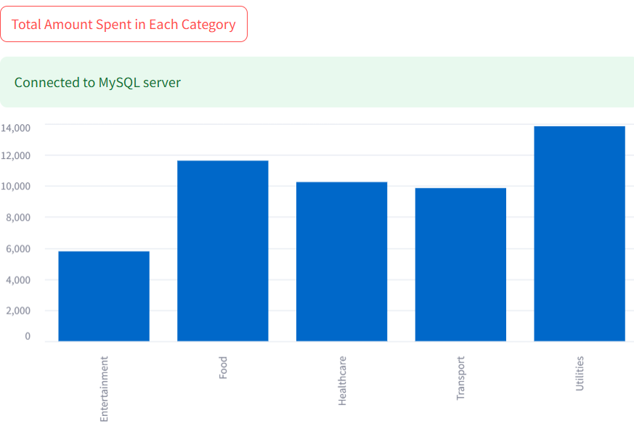

2. “SELECT Payment_Mode, SUM(Amount) AS Total_Amount FROM expenses GROUP BY Payment_Mode”
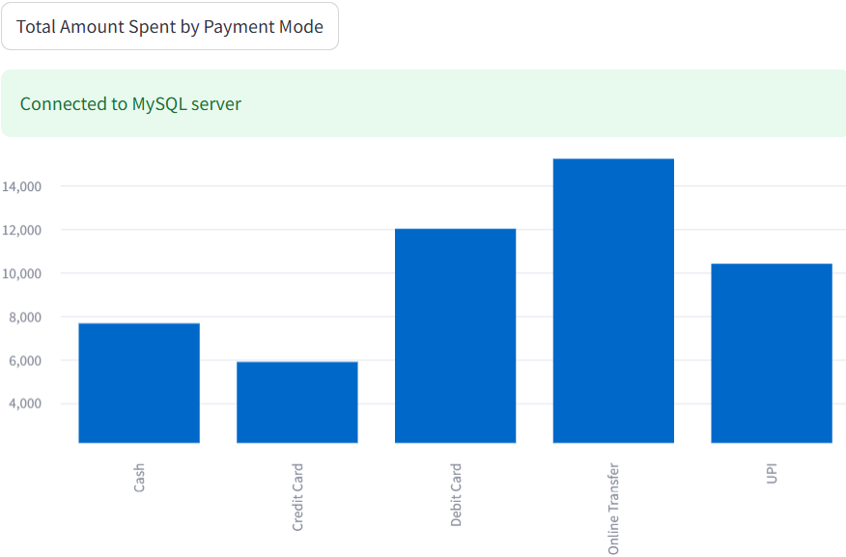
3. "SELECT SUM(Cash_back) AS Total_Cash_Back FROM expenses"
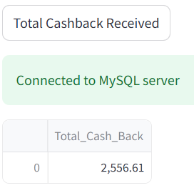

4. "SELECT Category, SUM(Amount) AS Total_Amount FROM expenses GROUP BY Category ORDER BY Total_Amount DESC LIMIT 5"
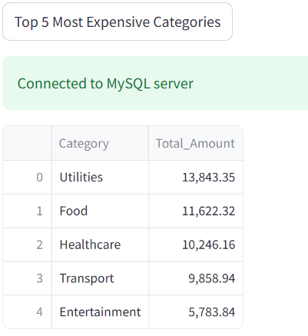
5. "SELECT Payment_Mode, SUM(Amount) AS Total_Amount FROM expenses WHERE Category = 'Transport' GROUP BY Payment_Mode"
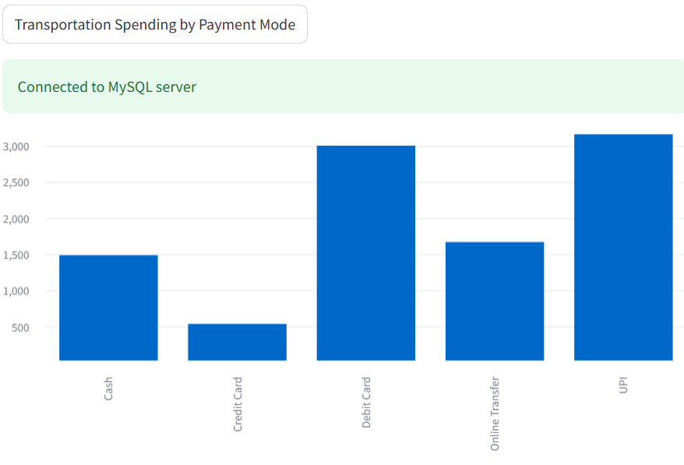

6. "SELECT * FROM expenses WHERE Cash_back > 0"
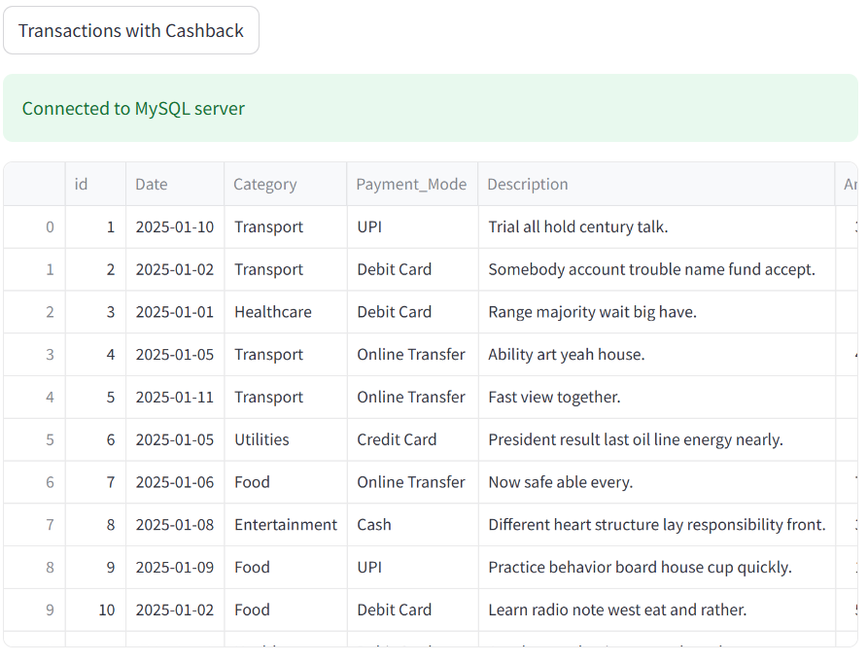
7. "SELECT DATE_FORMAT(Date, '%Y-%m') AS Month, Category, SUM(Amount) AS Total_Amount
FROM expenses
WHERE Category IN ('Travel', 'Entertainment', 'Gifts')
GROUP BY Month, Category
ORDER BY Month, Total_Amount DESC"
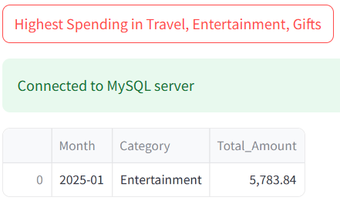
8. "SELECT Category, COUNT(*) AS Count, MONTH(Date) AS Month
FROM expenses
GROUP BY Category, Month
HAVING Count > 1"
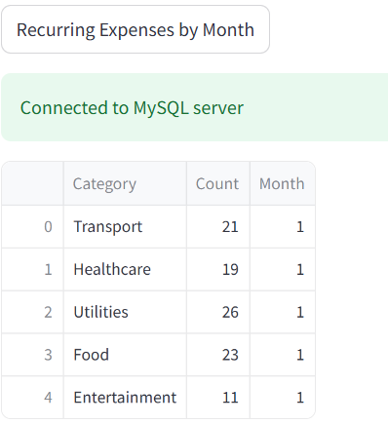
9. "SELECT DATE_FORMAT(Date, '%Y-%m') AS Month, SUM(Amount) AS Total_Amount FROM expenses GROUP BY Month ORDER BY Month"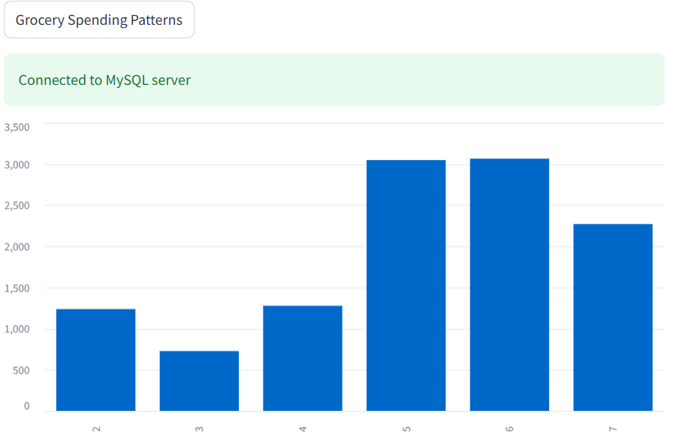

10. "SELECT Category, SUM(Amount) AS Total_Amount
FROM expenses
GROUP BY Category
ORDER BY Total_Amount DESC
LIMIT 1"
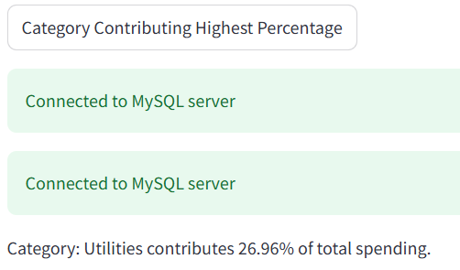
11. Created below is a Custom UI to Run custom query for other than predefined ones
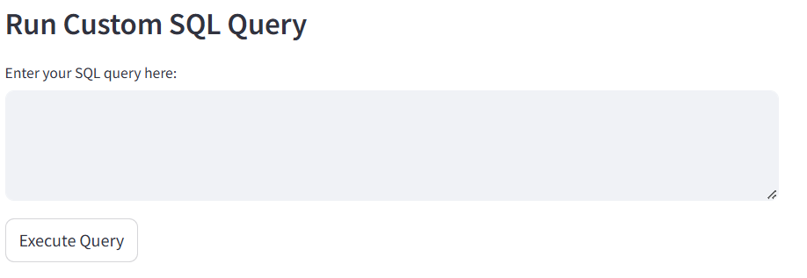

There are other Query’s that I created but in the faker generated data which I created I made it all in the same month so month vice query in streamlit all shows blank due to time constrains I didn’t work further into that error
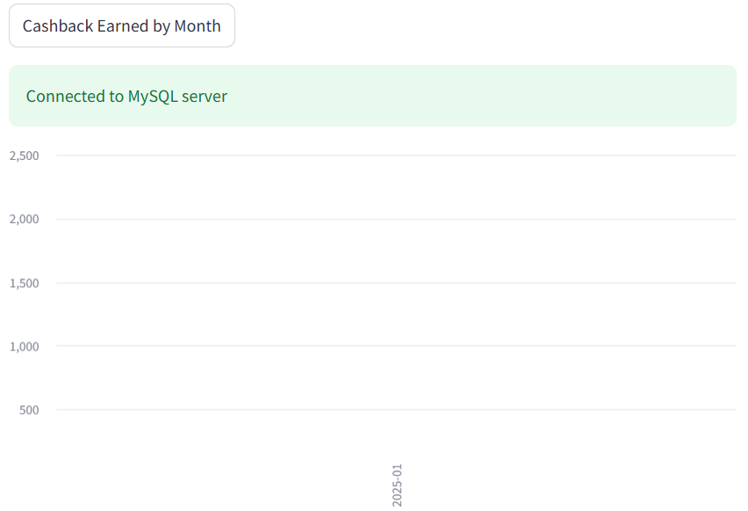

Conclusion
The Analyzing Personal Expenses project effectively demonstrates the use of Python, SQL, and Streamlit to simulate, analyze, and visualize personal financial data. By leveraging realistic datasets generated with the Faker library, the project offers a comprehensive view of spending patterns and trends across categories, months, and payment methods.
Key takeaways include the identification of high-priority expense areas, cashback opportunities, and actionable insights to optimize financial habits. The interactive Streamlit app enhances usability by providing dynamic visualizations and SQL query outputs, making expense tracking and analysis accessible for individuals and businesses alike.
This project not only showcases the practical application of data analytics and visualization tools but also emphasizes their potential in enabling informed decision-making and fostering better financial management practices.

